Dareen Njatou;Jingyuan Wu

NAIT CNT COMM1000 A02

N Kathleen van Dusen | April 13, 2025

Setting Up an Ubuntu Linux Virtual Machine on Windows 10/11 Using VMware Workstation

A Guide for IT students

April 13, 2025

N. Kathleen van Dusen

Academic Foundations, NAIT  
kathleenv@nait.ca

Dear Kathleen,

Enclosed is our report titled *Exploring How to Set Up an Ubuntu Virtual Machine on Windows 10/11 Using VMware Workstation: A Guide for Students and Developers in North America and Europe*, submitted for **COMM 1000**.

This report provides a comprehensive guide for installing and configuring an Ubuntu virtual machine using VMware Workstation. It also discusses common challenges and offers alternative solutions for users seeking different virtualization tools.

We would like to acknowledge the contributions of several resources and individuals in the development of this report. Artificial intelligence tools, including ChatGPT, were instrumental in drafting and refining our content. We also benefited from instructor feedback, editing software, and spell checkers, all of which contributed to the clarity and quality of our final submission.

The report is intended to help students and developers complete the virtualization setup process while gaining a deeper understanding of its practical applications in IT education and professional environments. It outlines system requirements, software acquisition, step-by-step instructions, troubleshooting advice, and includes visual aids to enhance comprehension.

If you have any questions or feedback, please feel free to contact us at **jwu45@nait.ca** or **dkinganjatou1@nait.ca**. We can also be reached by phone at **403-421-1111**.

Sincerely,

Kyootee Puhtootee

Dareen Njatou & Jingyuan Wu  
Computer Engineering Technology  
  
NAIT

Enclosure: Report – How to Set Up an Ubuntu Linux Virtual Machine on a Windows 10/11 OS Using VMware Workstation

Executive Summary

This report provides a comprehensive guide to setting up an Ubuntu Linux virtual machine on a Windows 10/11 system using VMware Workstation. It begins by outlining the concept of virtualization and its growing significance in IT, highlighting Ubuntu Linux as a preferred operating system for development, education, and testing due to its open-source nature and flexibility.

The report details essential system requirements, including a 64-bit processor, sufficient RAM, and administrative access, to ensure smooth installation and reliable performance. The methodology is based on secondary research, including industry documentation and technical guides, supplemented by practical implementation and firsthand testing.

Key findings present a step-by-step walkthrough of the virtualization setup process—from downloading VMware Workstation and configuring virtual machine settings to installing Ubuntu and performing post-installation configurations. The report also addresses common technical challenges such as performance optimization, network configuration errors, and storage limitations, providing actionable troubleshooting strategies.

In the analysis and discussion, the report explores the broader benefits of virtualization, including cost efficiency, security, and scalability, with a specific focus on how IT students can leverage virtual environments in their academic and professional development. It also evaluates alternative solutions such as Windows Subsystem for Linux (WSL2) and examines future trends in virtualization—such as cloud integration, AI-enhanced automation, and advanced security practices.

In conclusion, this report emphasizes the value of mastering virtualization technologies. By following the guide, students and developers can confidently create secure, flexible environments for learning, testing, and innovation.

Table of Contents

List of Figures vi

List of Tables vii

1 Introduction 1

1.1 Purpose 1

1.2 Scope 1

1.3 Limitations 1

1.4 Assumptions 1

1.5 Methods 2

2 Background 3

2.1 Context 3

2.2 Overview of Virtualization 3

3 Setting Up the Virtual Machine 4

3.1 Overview 4

3.2 System Requirements 4

3.3 Installing VMware Workstation 4

3.4 Setting Up Ubuntu Linux VM 8

3.4.1 Download Ubuntu Setup Iso 8

3.4.2 Configuring Virtual Machine Settings 9

3.4.3 Installing Ubuntu on the Virtual Machine 11

3.5 Summary 13

4 Analysis and Discussion 14

4.1 Overview 14

4.2 Benefits of Virtualisation 14

4.3 Use Cases for IT Students 14

4.4 Challenges and Solutions 15

4.5 Alternative Solutions (WSL2) 16

4.6 Future Implications 17

4.7 Summary 17

5 Conclusion 18

6 References 19

List of Figures

Figure 1: Locating VMware Workstation 5

Figure 2: Setting VMware Workstation for download 5

Figure 3: Downloading VMware Workstation 6

Figure 4: VMware Workstation Icon as found on the desktop 6

Figure 5: Screenshots of the VMware Workstation Setup 7

Figure 6: Screenshot of the Ubuntu Desktop download 8

Figure 7: Screenshot of the launch of VMware Workstation 9

Figure 8: Screenshots of the Steps to Install Ubuntu 10

Figure 9: Screenshots of the Ubuntu Screen Configuration Process 12

Figure 10: Ubuntu Screen from the Virtual Machine 13

Figure 11: Screenshot of the Windows Subsystem for Linux (WSL2) on a Windows 10 16

List of Tables

Table 1: Recommended Equipment and Material 4

# Introduction

## Purpose

The purpose of this report is to provide a comprehensive and structured guide for setting up an Ubuntu Linux virtual machine using VMware Workstation on a Windows 10/11 system. It aims to help students, IT professionals, and developers integrate Linux-based environments into their workflows for software development, cybersecurity testing, and network management. (VMware, 2023; Canonical, 2023).

## Scope

This report focuses on the technical process of setting up an Ubuntu virtual machine using VMware Workstation. It includes system requirements, step-by-step installation procedures, and configuration settings to ensure an optimized virtual environment. Additionally, it covers common troubleshooting steps and explores an alternative approach using Windows Subsystem for Linux (WSL2). (Microsoft, 2023).

## Limitations

This report specifically discusses VMware Workstation and Ubuntu as the virtualization software and guest operating system, respectively. Other hypervisors, such as VirtualBox or Hyper-V, and alternative Linux distributions are not covered in detail. Additionally, performance optimizations for high-intensity workloads are beyond the scope of this report. (Brown, 2022).

## Assumptions

The report assumes that users have access to a Windows 10/11 computer with sufficient hardware capabilities, administrative privileges for software installation, and basic knowledge of operating systems. (Lowe, 2022; Microsoft, 2023).

## Methods

The findings in this report are based on secondary research from industry documentation, technical guides, and direct testing of Ubuntu installation within VMware Workstation. We also drew on instructional material from our *CMPE 1100: Workplace Skills and Safety* course at NAIT, which provided a strong foundation in safe and effective practices for system setup and configuration (Chaulk, J, personal communication, 2025). The step-by-step procedures were validated through hands-on implementation to ensure accuracy and ease of use.

# Background

## Context

Virtualization is a key technology in modern computing. It allows users to run multiple operating systems on a single physical machine. This is especially useful for software development, testing, training, and security research. Instead of buying another computer, or install another operating system on the computer, users can create a virtual machine (VM) to try a different operating system without changing their main setup. In education, especially for IT students, virtualization makes it easy to explore different systems and learn technical skills in a safe environment (Choi, 2024). Ubuntu, a widely used Linux distribution, provides an open-source environment suitable for development and IT education.

## Overview of Virtualization

Virtualization involves the creation of virtual instances of computer systems, which function as separate environments within a host machine. VMware Workstation is a leading virtualization tool that enables users to run multiple operating systems simultaneously (Oven, 2023, pp. 11–24). It provides robust hardware emulation, networking configurations, and resource management tools, making it a preferred choice for students, developers, and IT professionals.

# Setting Up the Virtual Machine

## Overview

This section provides a step-by-step explanation of how to install VMware Workstation and set up an Ubuntu Linux virtual machine. The instructions are written for beginners and follow a simple and clear process.

## System Requirements

To download and install VMware workstation, the following system specifications are recommended:

Table 1: Recommended Equipment and Material

|  |  |
| --- | --- |
| **Item** | **Requirement** |
| Operating System | Windows 10 or 11 |
| Processor | 64-bit x86/AMD64 CPU (2011 or later) |
| RAM | Minimum 2GB (4GB or more recommended) |
| Storage | At least 1GB of free disk space |
| Admin Privileges | Required for installation |
| Internet Connection | Stable connection required for download |

Source: *Memory Requirements for Host Systems*, 2025

## Installing VMware Workstation

To begin the installation process, open a web browser and navigate to the [Free Downloads - Support Portal - Broadcom support portal](https://support.broadcom.com/group/ecx/free-downloads).. You need to make an account before downloading. In the search box, type “VMware Workstation” and click “Show results.” From the list, choose “VMware Workstation Pro”.

Figure 1: Locating VMware Workstation

图形用户界面, 应用程序, 电子邮件

AI 生成的内容可能不正确。

Source: Broadcom.com. (2025).

Figure 2: Setting VMware Workstation for download

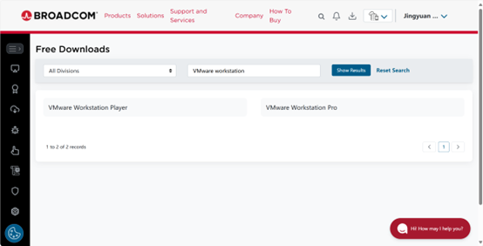

Source: Broadcom.com. (2025).

Choose the version for Windows. Agree to the terms and click “Download.” If it is your first time using the site, a message will pop up asking for extra verification. Click “Yes” and fill in your name and address. After that, the download will start by itself.

Figure 3: Downloading VMware Workstation

图形用户界面, 文本, 应用程序, 电子邮件

AI 生成的内容可能不正确。

Source: Broadcom.com. (2025).

When the download is done, find the .exe file. Right-click it and choose “Run as administrator.” If you see a pop-up from User Account Control, click “Yes.” The setup will open. Click “Next,” then read and accept the license agreement. Click “Next” again (Sander van Vugt, 2013).

Choose “Typical” if you want the default setup or choose “Custom” if you want to change something. Pick where you want to install the program, then click “Next.” Choose if you want shortcuts on your desktop and if you want automatic updates, then click “Next.”

Click “Install” to begin. Wait for the installation to finish. When it is done, click “Finish.” If asked, restart your computer.

Figure 4: VMware Workstation Icon as found on the desktop

To open VMware Workstation, find the shortcut on your desktop or in the Start menu and double-click it.

Source: Wu, J. (2025a)

Figure 5: Screenshots of the VMware Workstation Setup

VMware setup Wizard pop-up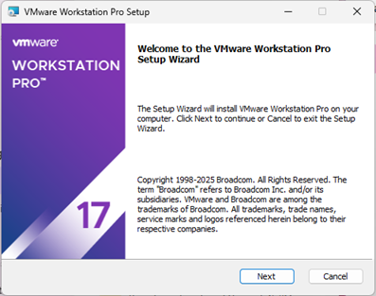

App Install and ready to be used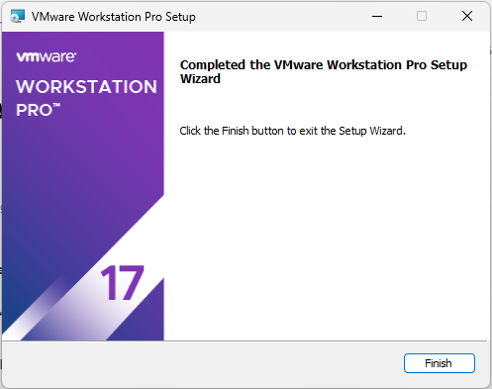

Click to install VMware

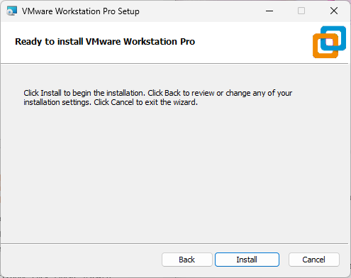

Source: Wu, J. (2025b)

## Setting Up Ubuntu Linux VM

### Download Ubuntu Setup Iso

To begin the process of installing Ubuntu, the first and most essential step is downloading the Ubuntu setup ISO file that contains the full Ubuntu operating system in a format that can be burned onto a USB drive or DVD for installation.

To download the ISO:

1. **Visit the official Ubuntu website**  
   Navigate to <https://ubuntu.com/download/desktop>. This is the safest and most reliable source to obtain the latest stable version of Ubuntu Desktop.

Figure 6: Screenshot of the Ubuntu Desktop download

Source: (2025). Broadcom.com. https://access.broadcom.com/default/ui/v1/signin/


Source: (2019). Ubuntu.com.

1. **Click "Download"**  
   After choosing your version, click the *Download* button. The file is usually around 4-6 GB, so ensure you have a stable internet connection and enough storage space.

This ISO file will later be used to create a bootable USB device, which is required for installing Ubuntu onto a physical machine or for use in a virtual environment.

### Configuring Virtual Machine Settings

First, we must launch VMware Workstation app. We do so from the Start menu or desktop shortcut.

Figure 7: Screenshot of the launch of VMware Workstation

Source: Njatou, D. (2025a)

Next, select the Ubuntu ISO file, assign a name and storage location, then allocate at least 4 GB of RAM, 2 CPU cores, and 20 GB of disk space. These steps provide a stable environment for running Ubuntu. See Figure 8, which shows the VM configuration process (Njatou, 2025).

Figure 8: Screenshots of the Steps to Install Ubuntu

Click Create a New Virtual Machine and select Typical (recommended).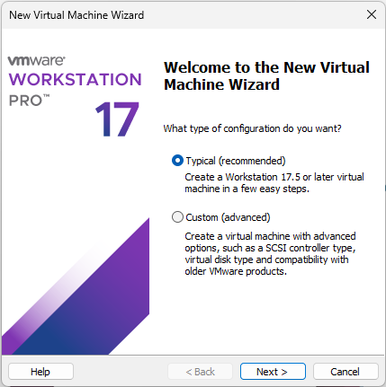

Choose Installer disc image file (ISO) and browse to locate the downloaded Ubuntu ISO file.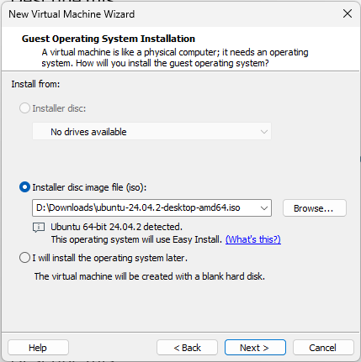

Assign a name (e.g., "Ubuntu VM") and specify the file location for virtual machine storage.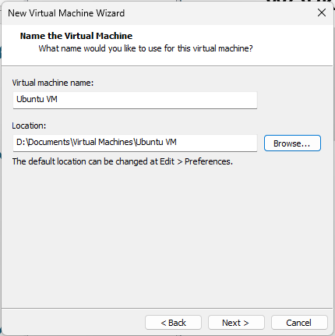

Assign at least 4GB RAM, 2 CPU cores, and 20GB or more of disk space. 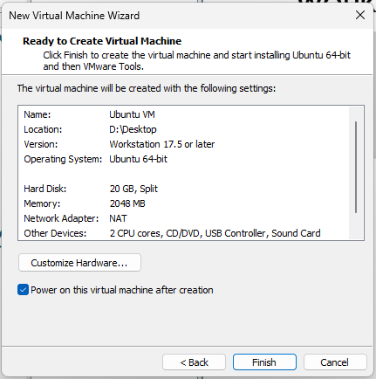

Source: Njatou, D. (2025b)

### Installing Ubuntu on the Virtual Machine

Once the virtual machine has been configured, the next step is to install Ubuntu:

1. **Start the Virtual Machine:** Click **Power on this virtual machine** to launch the Ubuntu installer from the mounted ISO file.
2. **Select Installation Type:** Choose **Install Ubuntu** from the options presented and follow the on-screen instructions.
3. **Partition the Virtual Disk:** When prompted, select **Erase disk and install Ubuntu**. This operation only affects the virtual hard drive within the VM, not the host system (Sander van Vugt, 2013).
4. **Create a User Account:** Configure your **username**, **password**, and system preferences during the setup wizard.
5. **Complete Installation:** Click **Install Now** and wait for the process to finish. Upon completion, restart the virtual machine to begin using Ubuntu (Choi, 2024).

These steps ensure a clean and stable Ubuntu installation within the virtual environment. Screenshots illustrating this process are shown in **Figure 9**. (flutter, 2024)

Figure 9: Screenshots of the Ubuntu Screen Configuration Process

Power on the virtual machine by clicking the designated button.

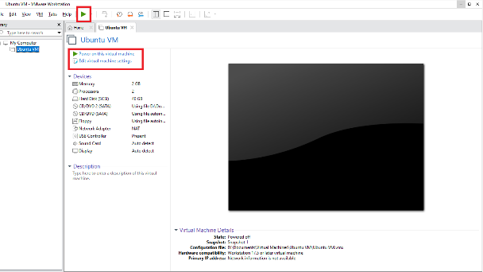

Creating your account

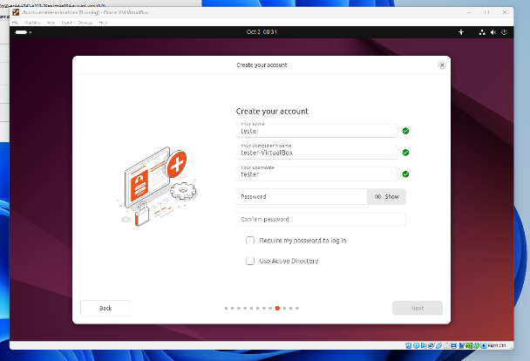

Installation Completed

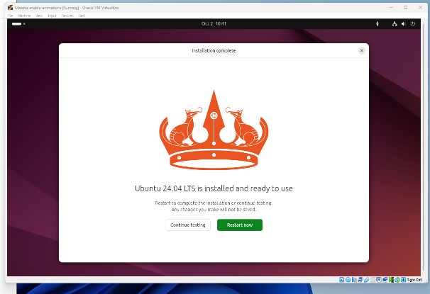

Choosing the language

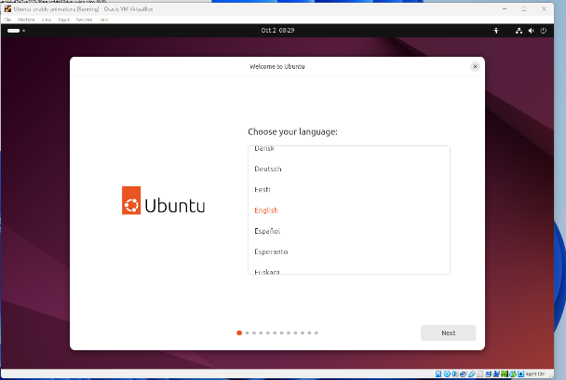

Reviewing the settings

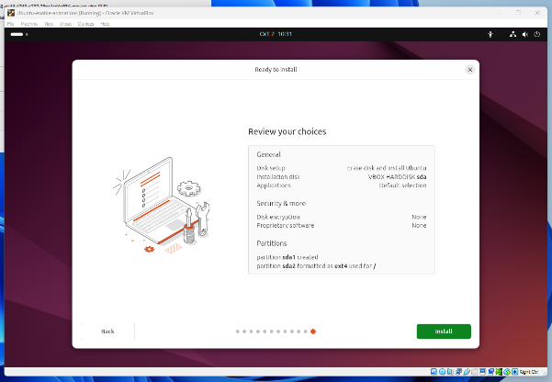

Source: flutter. (2024). *Ubuntu Installation Process*. GitHub.

Once the installation is complete, you’ll be prompted to reboot. After restarting, your newly installed Ubuntu virtual operating system will be ready for use.

Figure 10: Ubuntu Screen from the Virtual Machine

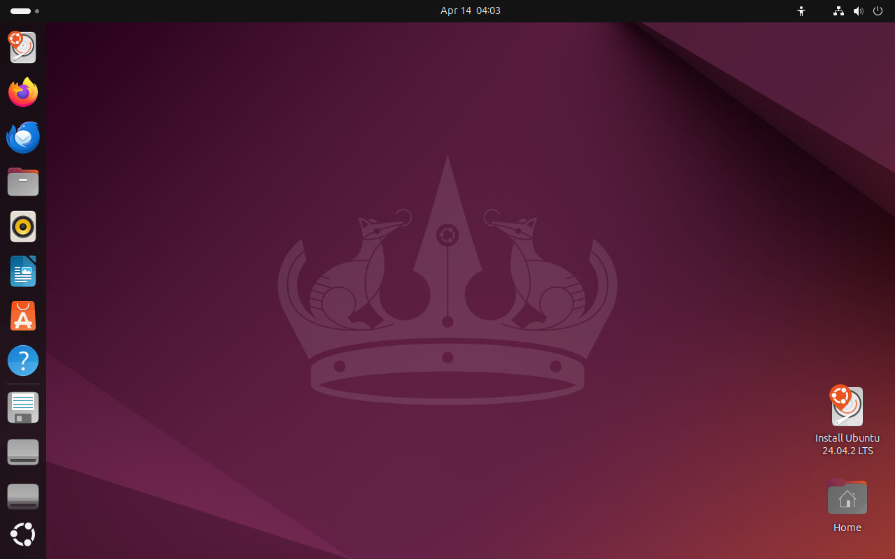

Source: Njatou, D. (2025c)

## Summary

To summarize the installation process of VMware Workstation on a Windows 10 or 11 system, this section included steps such as downloading the installer from the official Broadcom portal, running the installation as an administrator, and choosing the default setup options. These steps provide users with the necessary foundation to begin creating and managing virtual machines on their system.

# Analysis and Discussion

## Overview

Virtualization has gained widespread adoption in IT due to its efficiency, cost-effectiveness, and security benefits. However, challenges such as performance limitations, networking complexities, and compatibility issues can arise. This section explores solutions to these problems and the future implications of virtualization technology.

## Benefits of Virtualisation

Virtualization offers numerous advantages for both individuals and organizations:

* **Cost Savings:** By running multiple virtual machines on a single physical system, users reduce the need for additional hardware purchases, which helps cut down operational expenses significantly (Ali & Meghanathan, 2011; von Oven, 2024).
* **Flexibility:** Virtual machines allow for testing and experimentation with various operating systems and software setups without disrupting the host environment. This flexibility is especially valuable in development, IT training, and software deployment scenarios (Sander van Vugt, 2013; von Oven, 2024).
* **Security:** Since each virtual machine operates in an isolated environment, any errors, malware, or system failures remain contained, thereby protecting the host system and other virtual machines from contamination (Swift, Bershad, & Levy, 2003).
* **Scalability:** Organizations can dynamically allocate computing resources and deploy multiple virtual instances quickly to meet fluctuating workloads, making virtualization a key component of modern IT infrastructure (von Oven, 2024).

## Use Cases for IT Students

For IT students, virtualization plays a crucial role in their academic and professional development:

* **Software Development:** Virtual machines allow students to create and test applications in different operating environments (Ali & Meghanathan, 2011).
* **Cybersecurity Training:** Many cybersecurity courses use virtualized environments to simulate attack scenarios safely (Ali & Meghanathan, 2011).
* **Network Configuration and Testing:** Students can practice setting up and managing virtual networks before working on real infrastructure. (page 12 and 13)
* **Operating System Experimentation:** Provides hands-on experience with Linux, Windows, and other OS distributions. (Swift et al., 2003)

## Challenges and Solutions

Despite its numerous advantages, virtualization presents technical challenges that users must navigate effectively.

* **Performance Optimization:** Virtual machines can sometimes run slower due to limited resource allocation. To address this, users should assign adequate **RAM** and **CPU cores** and ensure that **hardware virtualization** is enabled in the system BIOS. Installing **VMware Tools** further improves performance by optimizing graphics, clipboard sharing, and seamless mouse integration (von Oven, 2024; Sander van Vugt, 2013).
* **Networking Configuration Issues:** Network connectivity problems may occur during virtual machine setup. Switching between **NAT** and **Bridged** network modes often resolves these issues. Additionally, setting **static IP addresses** or relying on **DHCP** can improve network stability and connectivity (von Oven, 2024).
* **Storage and Disk Management:** Virtual machines need adequate disk space to perform efficiently. Users should allocate sufficient **virtual disk storage** during setup and may consider enabling **disk compression** or **dynamically increasing disk size** within VMware Workstation to handle future storage demands (Roy, 2024; von Oven, 2024).

## Alternative Solutions (WSL2)

For users who require a lightweight alternative to full virtualization, **Windows Subsystem for Linux (WSL2)** provides a practical and efficient solution:

* **Performance Efficiency:** WSL2 allows Linux to run natively on Windows by leveraging virtualization behind the scenes, but without the overhead of a traditional virtual machine. This makes it ideal for users with limited hardware resources (craigloewen-msft, n.d.).
* **Seamless Integration:** Users can execute Linux-based command-line tools within Windows, enabling a smooth development workflow that blends both environments. This is particularly valuable for scripting, automation, and programming tasks (Choi, 2024).
* **Limitations:** While WSL2 excels at terminal-based tasks, it lacks built-in support for full graphical interfaces (GUIs). However, users can add GUI support using external tools or third-party packages if needed (craigloewen-msft, n.d.)

Figure 11: Screenshot of the Windows Subsystem for Linux (WSL2) on a Windows 10

Source: Popa, B. (2019, June 13). *Softpedia*.

## Future Implications

The future of virtualization is evolving rapidly, with several key trends shaping its development:

* **Cloud-Based Virtualization:** More organizations are shifting toward **cloud-hosted virtual machines**, minimizing the need for powerful on-site hardware and enabling users to access secure, scalable environments remotely. This shift supports both cost efficiency and remote collaboration (von Oven, 2024).
* **Integration with AI and Automation:** AI-powered virtualization platforms are emerging that can dynamically allocate system resources, predict performance demands, and adjust settings in real time—streamlining configuration and improving overall efficiency (Roy, 2024).
* **Enhanced Security Features:** As cyber threats become more advanced, virtualization platforms are responding with robust **security enhancements**, such as encrypted VM containers, sandboxed execution, and integrated monitoring tools to detect and mitigate intrusions before they spread (von Oven, 2024; Swift, Bershad, & Levy, 2003).

## Summary

This section discussed the benefits of virtualization, its relevance for IT students, common challenges and solutions, and alternative options like WSL2. It also explored emerging trends that will shape the future of virtualization technology.

# Conclusion

Setting up an Ubuntu virtual machine using VMware Workstation is a valuable skill for students and IT professionals, providing a versatile environment for software development, cybersecurity testing, and system administration. This report outlined the step-by-step installation process, discussed common issues and their solutions, and highlighted the future potential of virtualization technologies. By mastering virtual machine deployment and management, users can leverage powerful tools to enhance their learning and professional growth in the ever-evolving IT landscape.

# References

Ali, I., & Meghanathan, N. (2011). Virtual Machines And Networks - Installation, Performance, Study, Advantages And Virtualization Options. *International Journal of Network Security & Its Applications*, *3*(1), 11–12. https://doi.org/10.5121/ijnsa.2011.3101

Broadcom. (2025). Free downloads [Screenshots]. Broadcom.com. <https://access.broadcom.com/default/ui/v1/signin/>

Brown, D. (2022). *Virtualization essentials*. Wiley.

Canonical. (2023). *Ubuntu Desktop documentation*.

<https://ubuntu.com/tutorials>

Choi, B. (2024). Introduction to Python Network Automation Volume I - Laying the Groundwork. In *Apress eBooks*. https://doi.org/10.1007/979-8-8688-0146-4

craigloewen-msft. (n.d.). *Install WSL*. Learn.microsoft.com. https://learn.microsoft.com/en-us/windows/wsl/install

flutter. (2024). *Flutter detects animations as disabled on Ubuntu (when they’re not) · Issue #155982 · flutter/flutter*. GitHub. https://github.com/flutter/flutter/issues/155982#issuecomment-2387958637

*Get Ubuntu | Download | Ubuntu*. (2019). Ubuntu. <https://ubuntu.com/download>

Lowe, D. (2022). *Networking All-in-One For Dummies*. Wiley.

*Memory Requirements for Host Systems.* (2025). Broadcom.com. <https://techdocs.broadcom.com/us/en/vmware-cis/desktop-hypervisors/workstation-pro/17-0/using-vmware-workstation-player-for-linux-17-0/introduction-and-system-requirements-linux/host-system-requirements-for-workstation-player-linux/memory-requirements-for-host-systems-player-linux.html>

Microsoft. (2023). *Windows Subsystem for Linux documentation*.

<https://learn.microsoft.com/en-us/windows/wsl/>

Njatou, D. (2025a). *Screenshot of the launch of VMware Workstation* [Screenshot]. Personal collection.

Njatou, D. (2025b). *Steps to install Ubuntu using VMware* [Screenshot]. Personal collection.

Njatou, D. (2025c). *Ubuntu screen from the virtual machine* [Screenshot]. Personal collection.

Oven, P. von. (2024). *Learning VMware Workstation for Windows: implementing and managing VMware’s desktop hypervisor solution* (1st ed.). Apress L. P. https://doi.org/10.1007/978-1-4842-9969-2

*Popa, B. (2019, June 13). Softpedia. Softpedia. https://news.softpedia.com/news/windows-subsystem-for-linux-2-wsl-2-now-available-for-windows-10-users-526392.shtml#sgal_0*

Roy, M. (2024, May 13). *VMware Workstation Pro: Now Available Free for Personal Use*. VMware Workstation Zealot. https://blogs.vmware.com/workstation/2024/05/vmware-workstation-pro-now-available-free-for-personal-use.html

Sander van Vugt. (2013). *VMware Workstation - No Experience Necessary*. Packt Publishing Ltd.

Swift, M. M., Bershad, B. N., & Levy, H. M. (2003). Improving the reliability of commodity operating systems. *ACM SIGOPS Operating Systems Review*, *37*(5), 207–222. https://doi.org/10.1145/1165389.945466

VMware. (2019, December 19). *VMware – Cloud, Mobility, Networking & Security Solutions*. VMware. <https://www.vmware.com/>

Wu, J. (2025a). *VMware Workstation icon on desktop* [Screenshot]. Personal collection.

Wu, J. (2025b). *VMware Workstation setup wizard screenshots* [Screenshot]. Personal collection